Backing up the students records.
This Compresses the student records directory into a .tar.gz archive.
Saves it in a dedicated ~/backups folder.
Logs each backup activity with a timestamp.
Schedueled daily at 22:00 hrs via cron

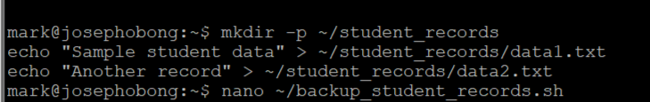
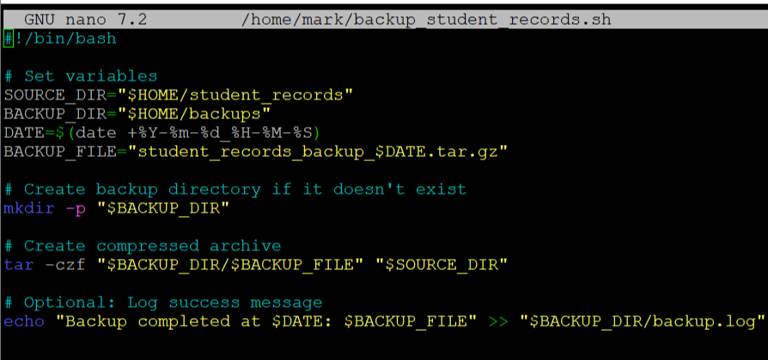
Making it executable and setting it up to run at 22:00 pm daily with the crontab command
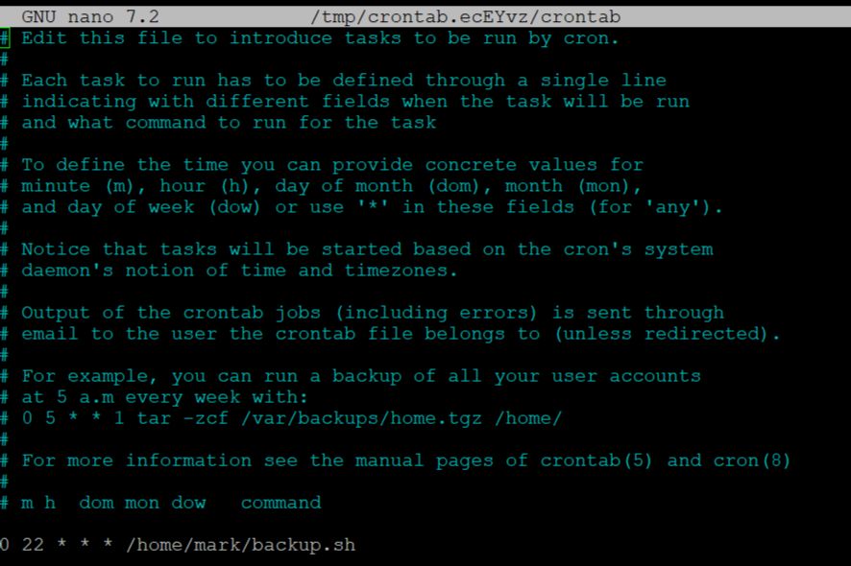
2.System monitoring
Continuously checks RAM usage percentage.
Sends an alert using notify-send when RAM usage exceeds 80%.
Logs alerts with a timestamp.

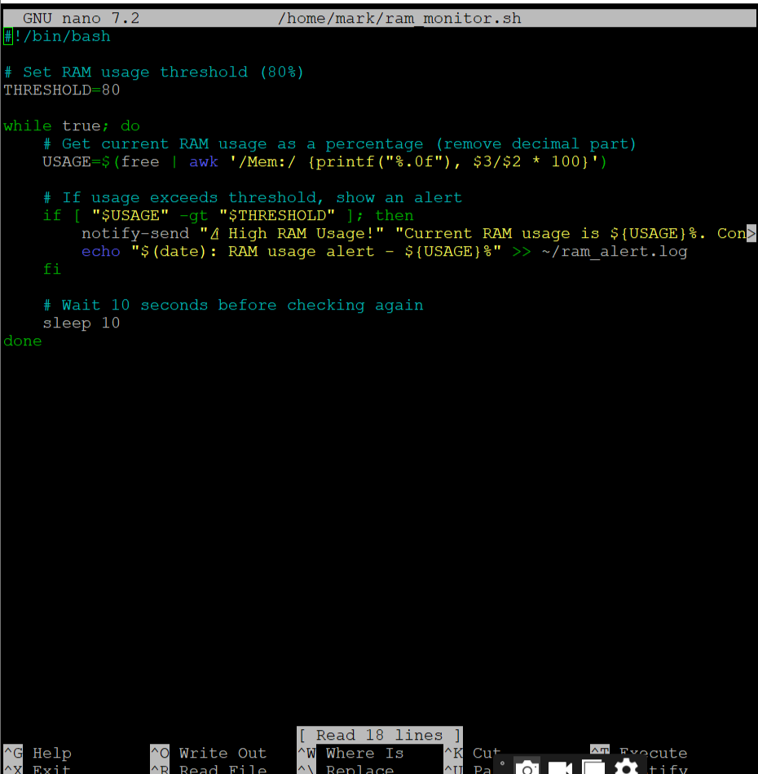
3.Making scheduled logouts.
Sends a warning message to logged-in users using notify-send.
Waits 60 seconds to allow users to save work.
Forcefully logs out all users (excluding root).
Schedule: Daily at 13:00 hrs via cron

This command opens up the logout bash.
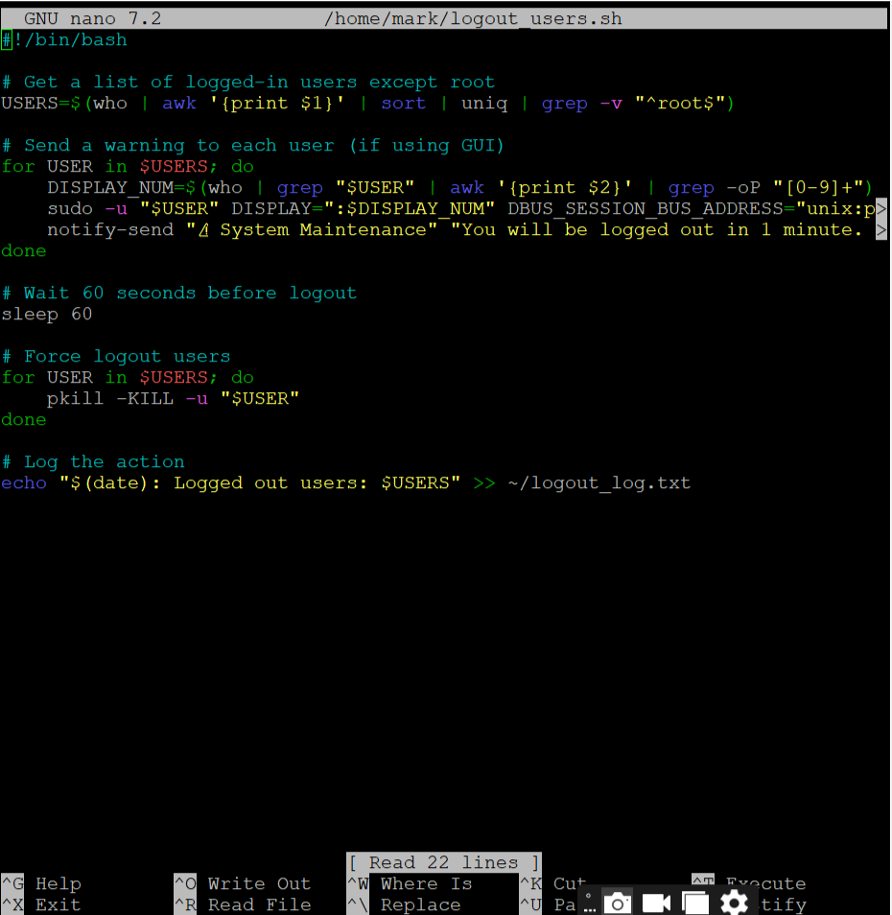
Making the code executable.
Schedule it via the root crontab
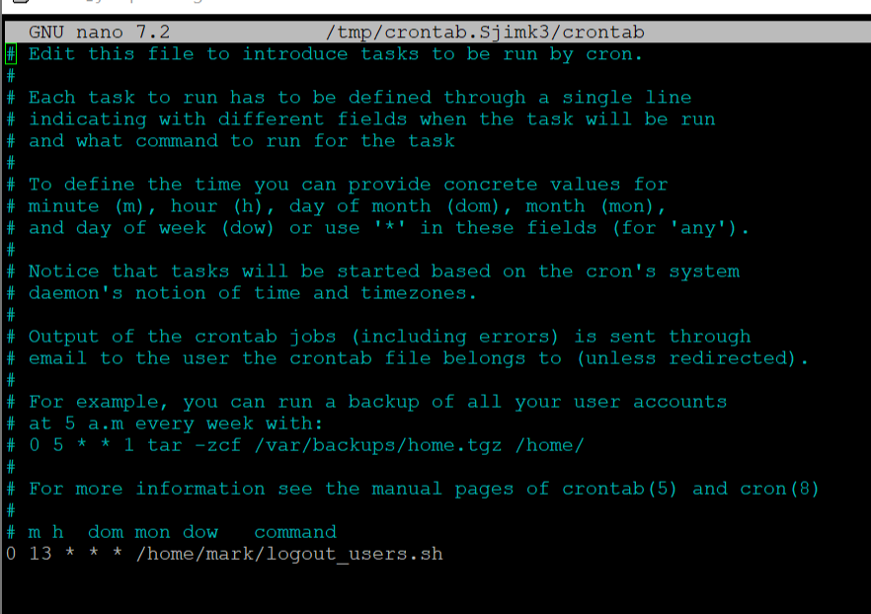
This is a test that logs out the user
Security Considerations
- User Data Protection
The logout script sends a one-minute warning using notify-send, giving users a chance to save their work.
- Restricted Permissions
The logout script is run using the root user's crontab, preventing unauthorized logouts and ensuring the script can terminate other user sessions.
- Backup Integrity
  - Archives are timestamped to prevent accidental overwriting.
  - All backup operations are logged to backup.log.
- Log Files for Auditing
Each script creates a log file for transparency and troubleshooting:
  - backup.log
  - ram_alert.log
  - logout_log.txt
Testing Procedures & Results
Backup Script
- Test: Ran manually and via cron.
- Result: Archive created in ~/backups/ folder. Verified contents using tar -tvf.
RAM Monitoring
- Test: Used stress tool to simulate high RAM usage.
- Result: Alert was triggered at ~81% RAM, and logged correctly.
Logout Script
- Test: Triggered manually and scheduled via cron.
- Result: Warning displayed, users logged out after 60 seconds.

5. Future Enhancements
- Email Alerts
Use mail or ssmtp to send email alerts when RAM is high or backup fails.
- Cloud Backup Integration
Automatically upload backups to a cloud service (Google Drive, Dropbox, etc.) for redundancy.
- Graphical Dashboard
Create a web-based dashboard (e.g., with Python Flask) to visualize system metrics and script logs.
- Smart Logout Handling
Detect if applications with unsaved work are open and notify accordingly (e.g., check for open LibreOffice or code editors).
- Encrypted Backups
Use gpg to encrypt backup files for extra security before storing or uploading.

Youtube video.
https://youtube.com/shorts/wBI8AdNKKAs

